**USER MANUAL STUDENT PAGE**

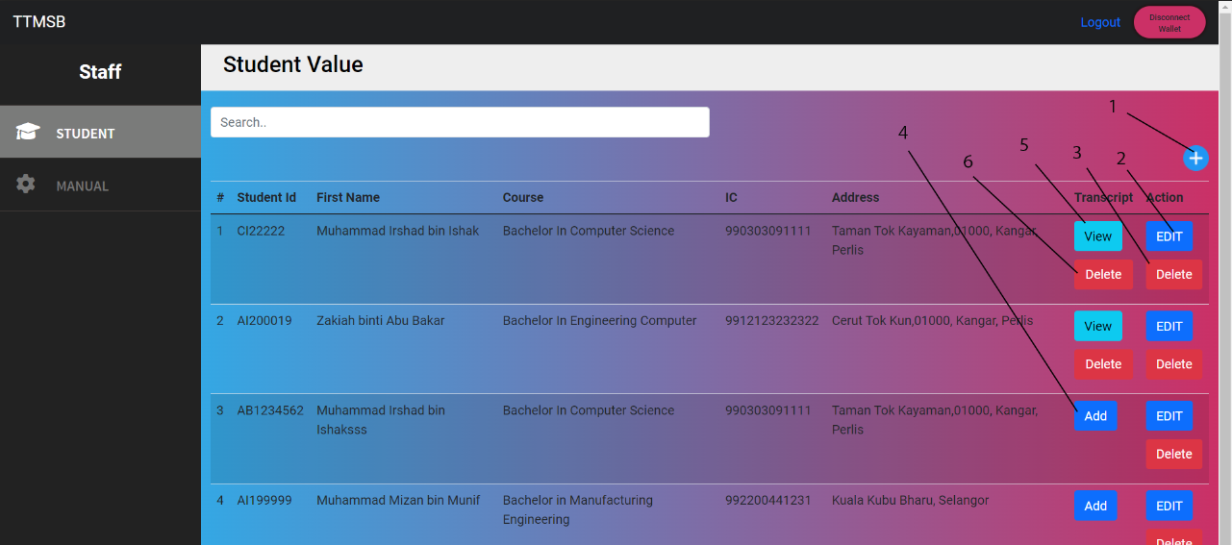

1. **Add Student**
2. **Edit Student**
3. **Delete Student**
4. **Add Transcript**
5. **View Transcript**
6. **Delete Transcript**

**ADD STUDENT**

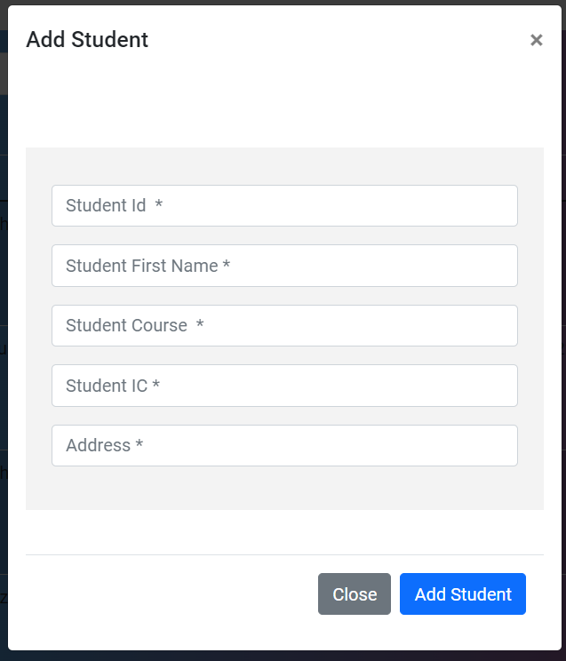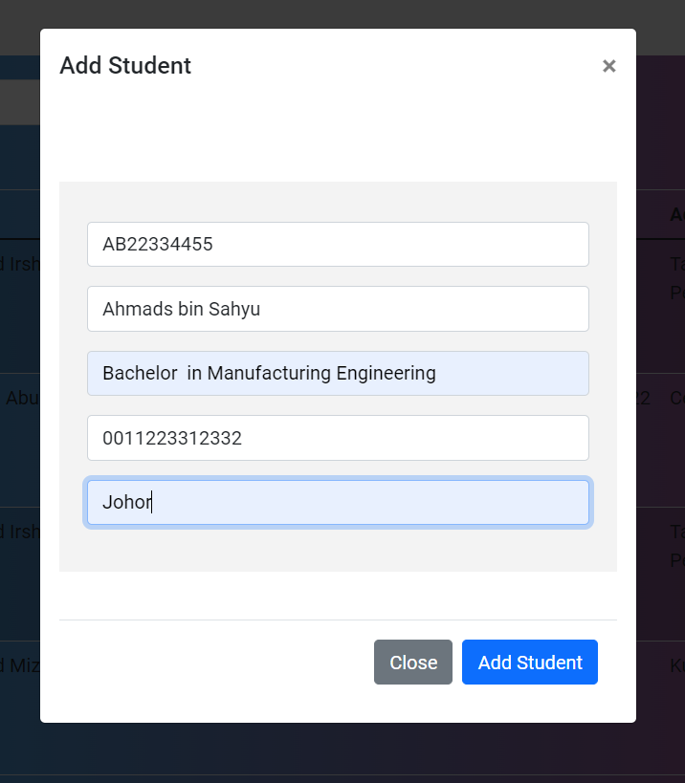

**User can add student by input Student Information in the form**

**Student ID, Student First Name, Student Course, Student IC and Address**

**EDIT STUDENT**

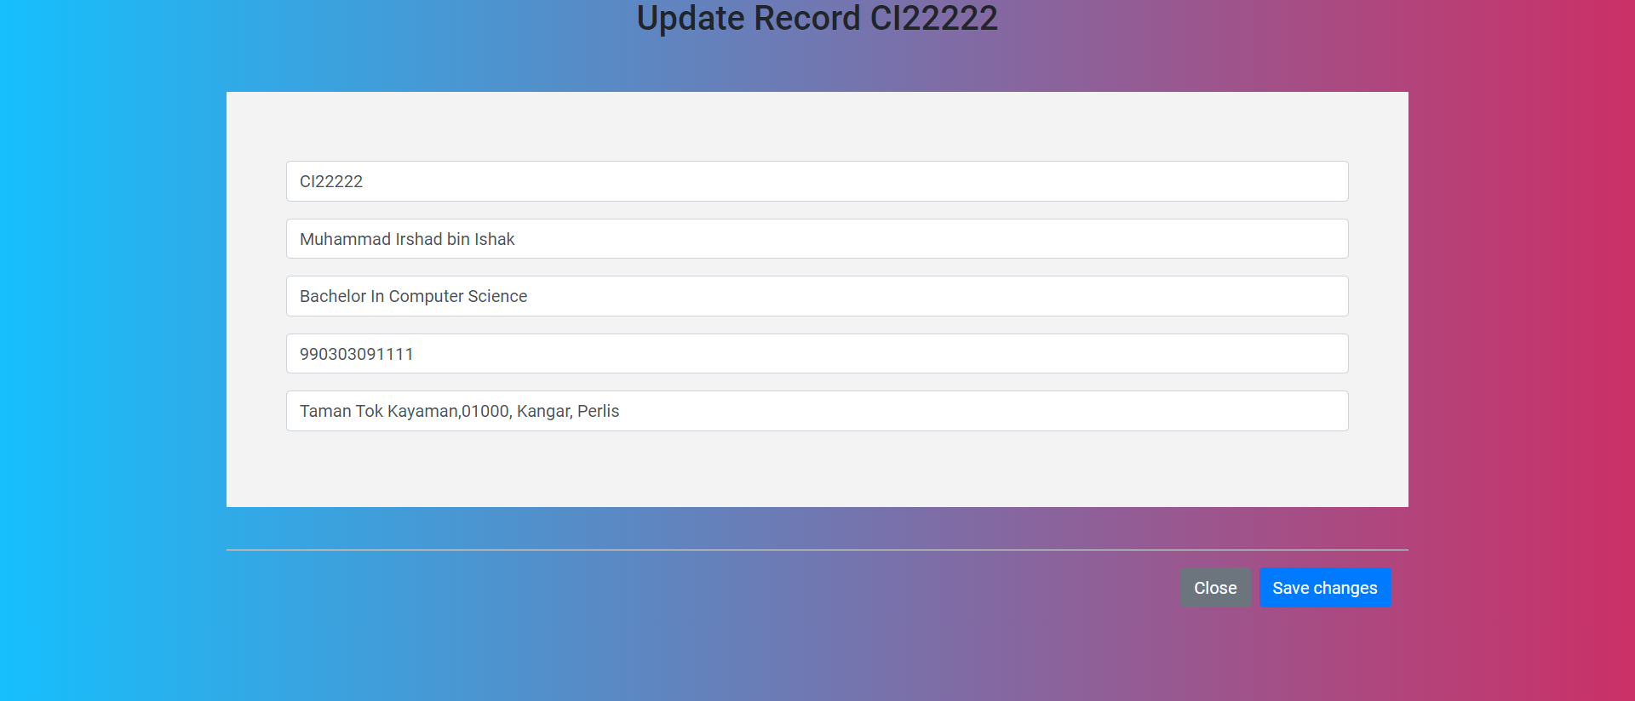

**User can edit student by input updated Student Information in the form**

**Student ID, Student First Name, Student Course, Student IC and Address**

**Delete Student**

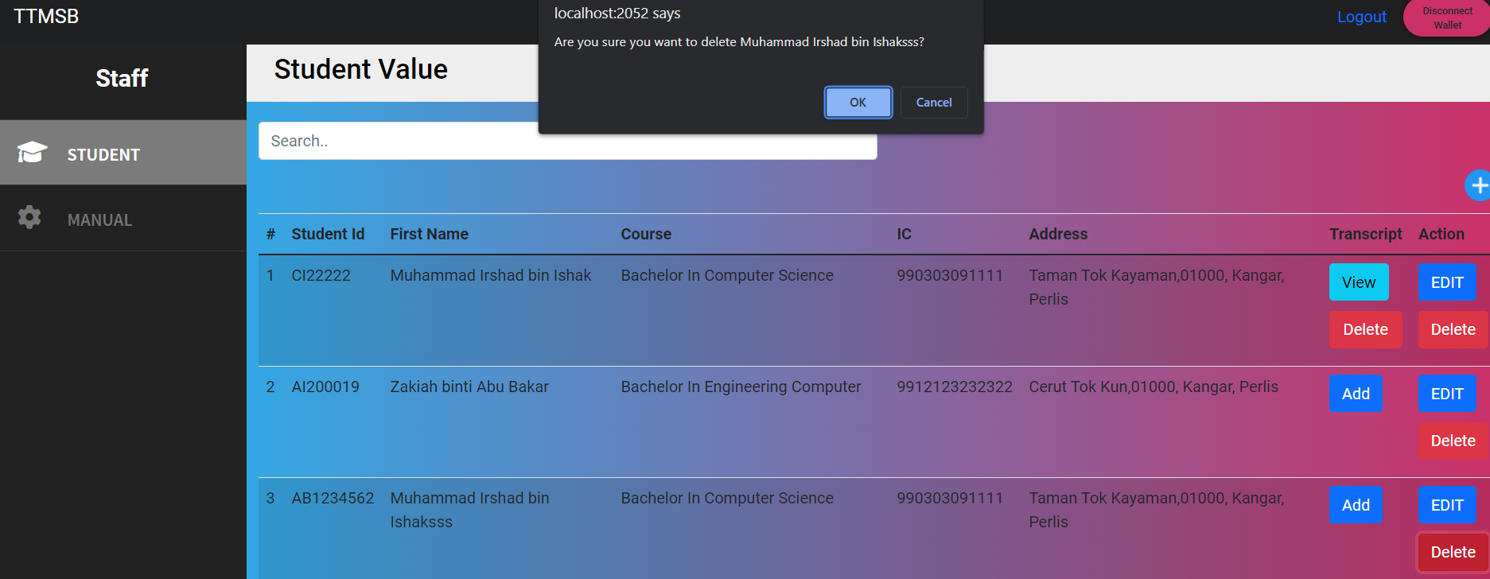

**User can delete student**

**Alert message will appear student name for confirmation**

**ADD TRANSCRIPT**

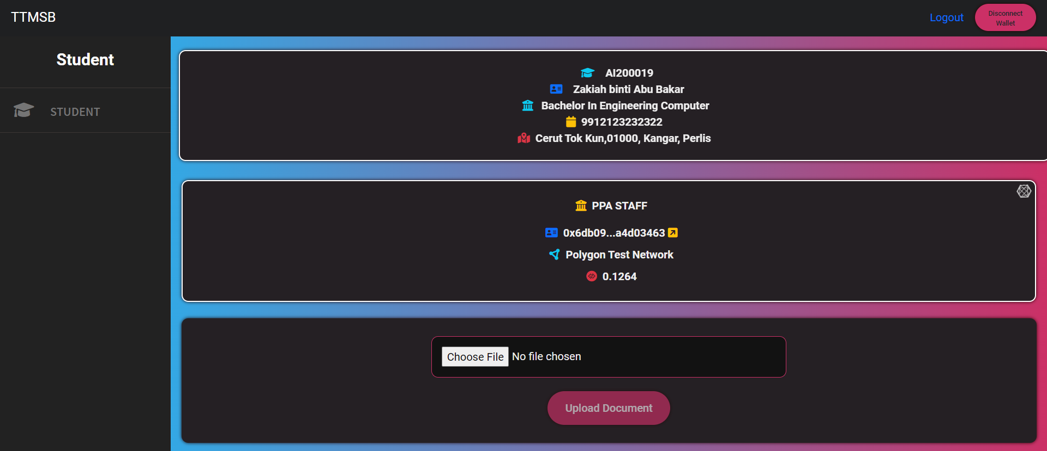

**Information Student will be shown and Staff Blockchain ID will be shown**

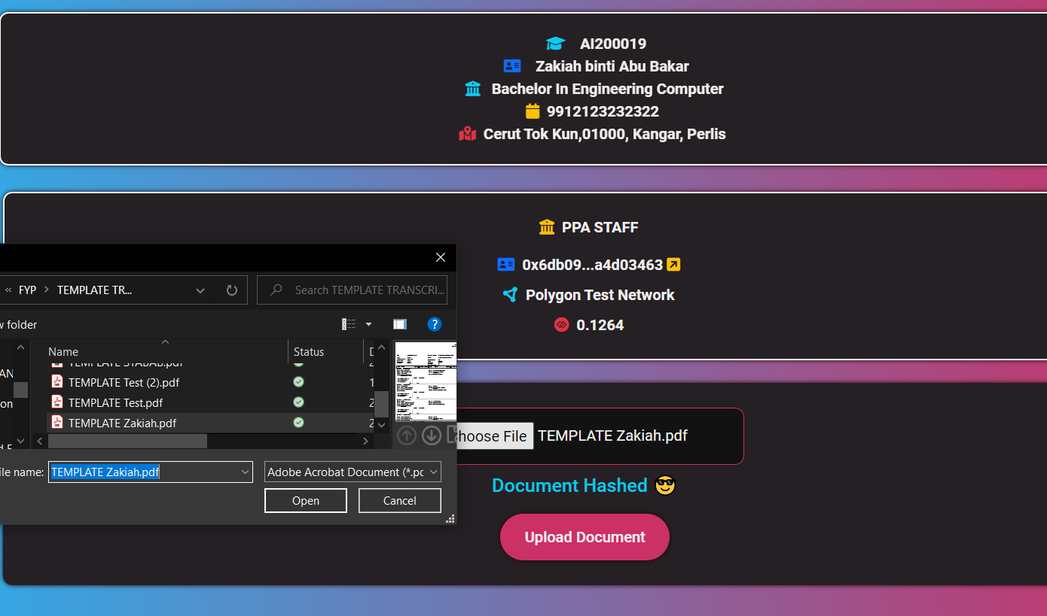

**Staff require to upload transcript Student for upload into blockchain**

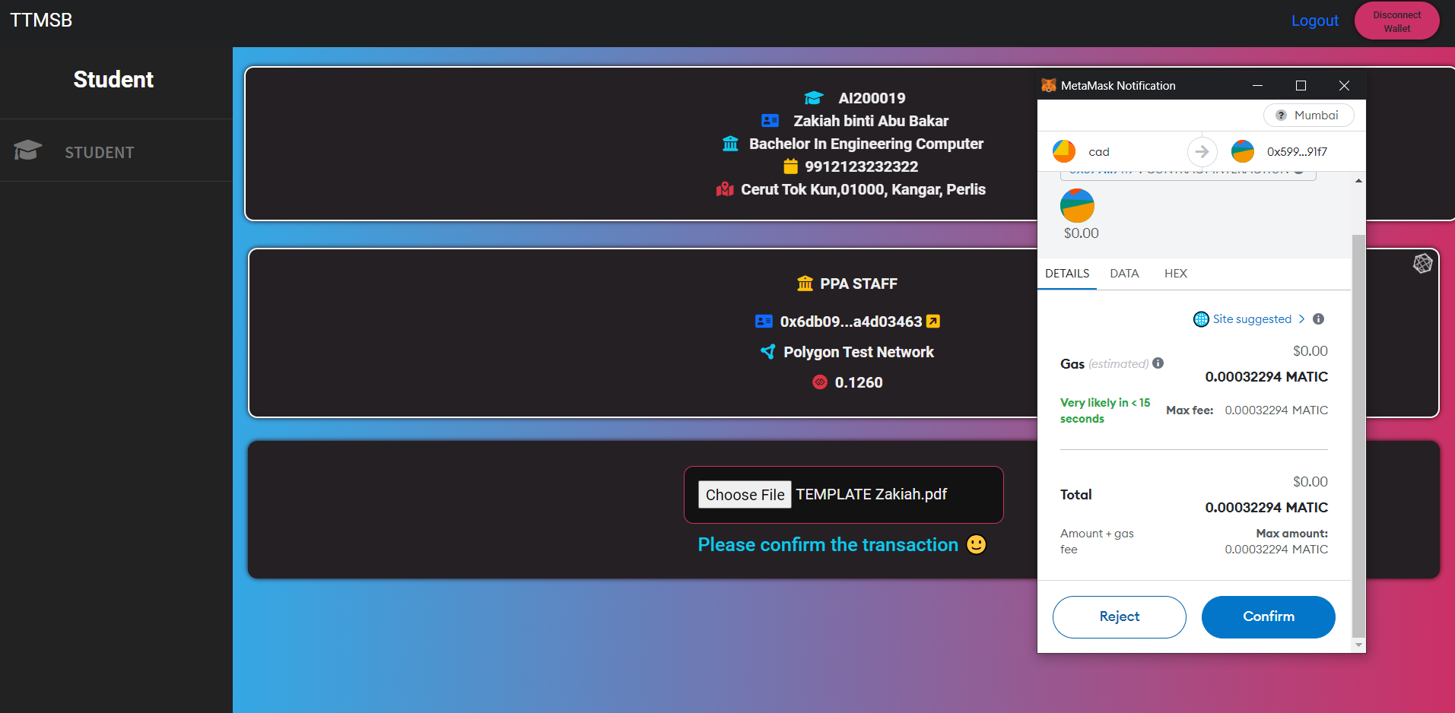

**The file upload will be hash**

**Click confirm to add to blockchain**

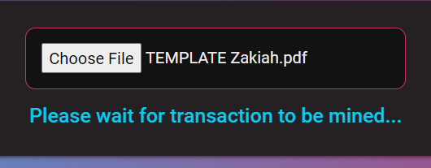

**Wait for transaction into the blockchain will complete**

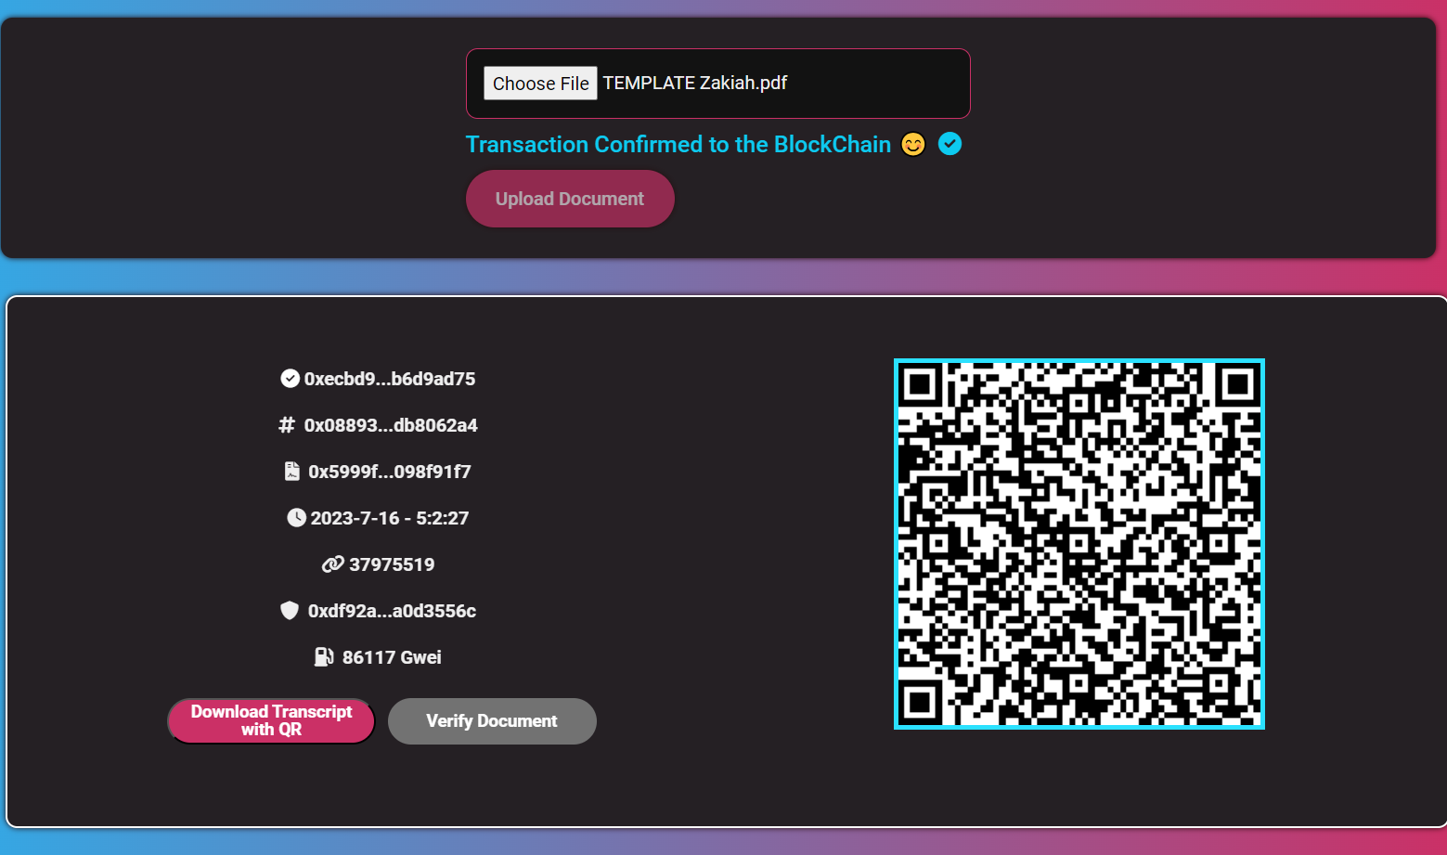

**The generate QR will display**

**The button Download Transcript with QR will download the transcript embedded with QR**

**The button Verify will redirect to verify page to verify the transcript**

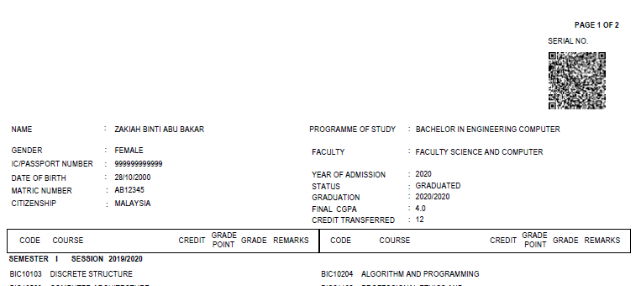

**Output of Transcript Embedded with QR**

**View Transcript**

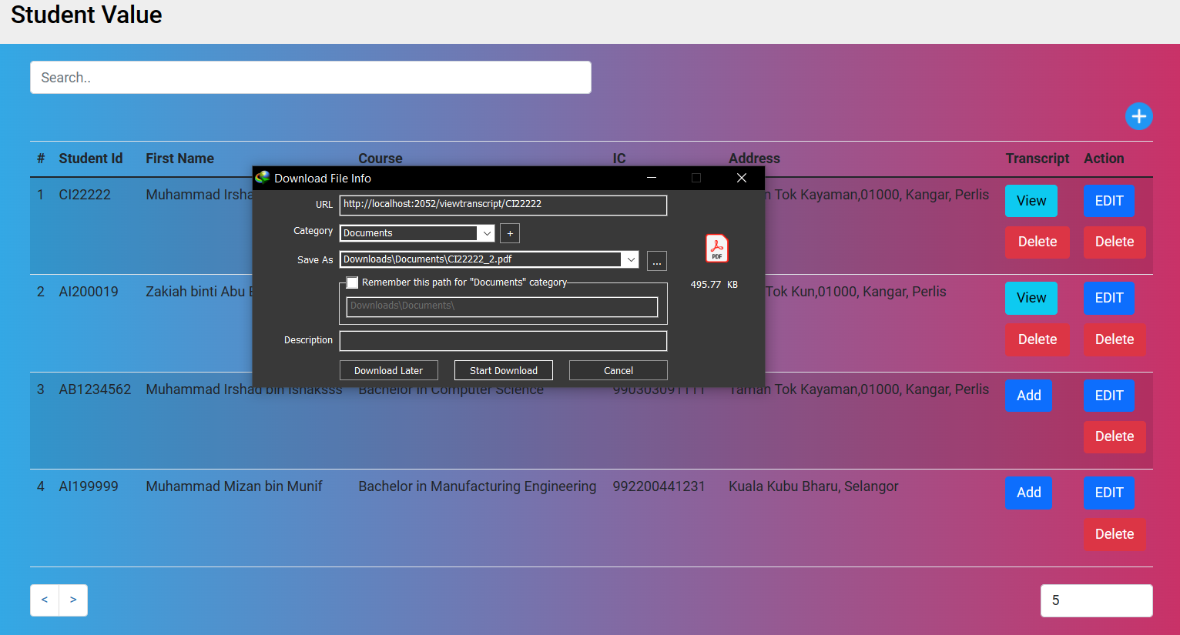

**Button View Button will download the transcript**

**Delete Transcript**

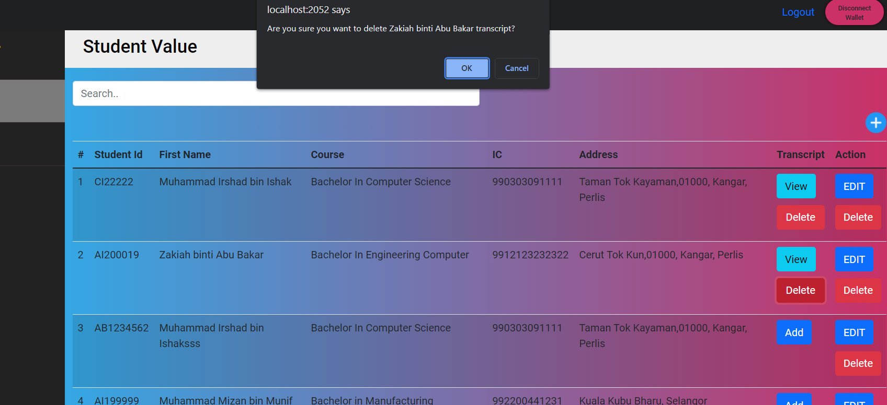

**Alert message will appear student name for confirmation**